**WORK INSTRUCTIONS FOR_** **REFRACTORY WORK IN HOT BLAST SYSTEM**

* Objective : - Maintaining healthiness of Refractories in Hot Blast System.
* Scope : - Hot Blast Stoves
* Ref. : -
* Responsibility : - Operation In-charge, Engineer in charge & workmen on the job

PPE to be used :

* Helmet, safety shoes Dust mask, hand gloves, safety belt, and complete sealed goggles, CO monitor, safety over coat Face shield
* Activity No 1 :Shifting of checker bricks on top of stoves
* Activity No 2 :Cooling of Stove
* Activity No 3 :Dismantling, Inspection & Erection of Checkers inside HBS
* Activity No 4 :Bustle main repair/ relining
* Activity No 5 :Hot Blast main repair/ relining
* Activity No 6 :Waste gas main & chimney (Stack) repair/ relining

**Aspect – impact**

|  |  |
| --- | --- |
| Dust generation | Air pollution |
| Scrap generation | Resource depletion |
|  |  |
| Oil spillage | Land contamination & Resource Depletion |

**Hazards identified**

**Mechanical**

1. Fall of bricks, steel, hammer, etc on human body as well as on HBS equipments
2. Trapping in between objects.
3. Impact due to object, bricks
4. Snapping of wire rope of slings
5. Tripping of person with compressed air hoses
6. Fall of flange and plate while fixing
7. Failure of hoist and slings
8. Collapse of checker layers
9. Back Pain due to sudden or heavy load like checkers, castable bags.
10. Fall of person inside combustion chamber
11. Fall of person from platform, staircase
12. Failure of platform due to overloading
13. Failure of rope / sling of 5 T hoist
14. Flying of coupling of fan

**Physical**

1. BF Gas inhalation
2. Hot surface
3. Dust
4. Splashing of castable, mortar into eyes
5. Heat
6. Burn injury due to hot exhaust from fan discharge
7. Strain due to carrying heavy weight.

**Electrical**

* 1. Electrical shock
  2. Improper illumination

**Behavioral Hazard:**

1. Workmen under influence of alcohol
2. Violation of procedure
3. Not wearing PPE’s
4. Not concentrating while operating hoist
5. Using mobile while working

**Hot blast system is confine space (REFER CENTRALISED CONFINED SPACE ENTRY SOP-VL/IMS/VAB/SP44 Y). The system includes- Hot blast stove, Hot blast main, Bustle main, Waste gas/ flue duct & chimney.**

**FOR MORE DETAILS REFER CENTRALISED CONFINED SPACE ENTRY SOP-VL/IMS/VAB/SP44 Y**

Confined Space Checks before job start up:

1. Before Entering in Confined Space ensure –
2. Inside temperature should be less than 40°C
3. CO Level should be 0 ppm
4. Attendant must ensure proper illumination, if illumination not found ok, he must inform concern electrical person to provide hand lamp or halogen.
5. Take the work permit from production-in-charge, Safety, electrical, mechanical for entering Confined Space.
6. The workmen (Entrant) who is trained and certified by SBU Head and having valid confined space gate pass should perform the activity and he can be replaced(in emergency) only by certified entrant .
7. A standby (attendant) who is trained and certified by SBU Head and having valid confined space gate pass should perform the activity and he can be replaced(in emergency) only by certified attendant .
8. Standby person who shall be positioned outside the confined space , must have no other duties other than monitoring people and conditions inside the confined space and coordinating with rescue personnel (he must have contact number of rescue team members) if required.
9. Standby (Attendant) person has to log down the In/Out entry of all entrants and ensure that entrant should be come out after 30 minutes from confined space for normal jobs.
10. In some cases In/Out time may be relaxed /extended based on the risk involved in the particular confined space.
11. Check Internal atmosphere of the space for sufficient oxygen content (19.5% to 23.5 %) flammable gases and vapours, and the potential for toxic air contaminants by the use of multi gas detector, if required use pump with extension before entering. If there is any deviation, do not enter into confined space.
12. Check for the presence of Chemical asphyxiates such as Carbon monoxide (CO gas detector).It should be 0 PPM
13. Check inside temperature and it should be is in the tolerable range (25°C to 40°C). If the temperature is not within limits then appropriate ventilation to be used to normalize the temp.
14. Check for suitability of equipment that is used at the confined space.
15. Check any dust due to which visibility is reduced or respiratory tract is irritated.
16. The sign-in and sign-out of all persons entering into confined Space should be recorded.
17. Use 24V DC supply illumination to avoid electrocution/electric shock.
18. Cutting or welding jobs inside the confined space should be carried out after checking for any explosive environment (LEL should be <10%) and by providing localized suction or heavy duty exhaust systems to prevent accumulation of gases inside the space.
19. Isolation of related equipment of respective confined space with personal LOTO lock to be ensured.

Please note that this area is considered as Confined Space so needs to maintain the checklist of the activity. All in time and out time details of entrants, levels of gases to be logged in checklist (yellow copy) or in any alternate document and to be documented.

**Role of Rescue Team**

**As the work is being carried out inside confined Space, in an emergency victim can be taken out by use of rescue apparatus such as stretcher. However attendant should call ambulance which is fully equipped. However rescue team members should take a charge of the situation*.***

**Activity No 1: Shifting of checker bricks on top of stove**

1. Initially materials to be stacked on flat ground near stoves area where access is there for 5 ton hoist. This area to be barricaded (1mts outside stacking area)
2. Small quantity materials like mortar, castable, hoses, poker rods, insulating bricks, dense bricks for inspection door, plumber and lancing pipe chain etc. will be shifted near inspection door platform before opening of inspection door.
3. Checker bricks will be shifted manually or by electric hoist.
4. For manually shifting, each helper should carry single brick at a time (weight of each brick 9 kg). Required no of helpers will be worked at a time for shifting and bricks will be forwarded from one helper to another.
5. Max 2 layer staking of checker should be there on the platform above 5 ton hoist and HBIV platform leaving walking space.
6. Stove area below the working platform should be barricaded.
7. Cage will be used for shifting bricks by hoist (When cage is moving people should not stand below it). Only trained company workman should operate it. Bricks will be stacked below 5 ton hoist platform in max 2 layer followed by manually shifting to the inspection door platform.
8. Ensure that bricks shifted being uniformly placed over the platform and not exceeding a weight of 200kg/m2

I. stack one over the other at dome platform

**Activity No 2:** **Cooling of Hot Blast Stove**

* 1. Put the HBS system in semi auto.
  2. Isolate the concern stove after last blast cycle
  3. Water-seal the gas line and put lockout pad on the water sealing valve and keep slight water overflow from the seal .
  4. take shutdown (elec & mech) of gas shut off valve. .
  5. Steams purge the gas line and evacuate it from bleeder valve.
  6. Open chimney valve.
  7. Withdraw the stove from PLC system
  8. Output fuses related to stove valves (HBV, CASV, CBBV, and CBV) should be removed. Take electrical shut down of above. Remove hoses and loop them. Lock all valves mechanically.
  9. Remove the gas shut off valve and put blank on GRV side as well as stove side.
  10. Further cooling procedures if other two stoves are in operation:
      1. Open stove dome inspection door brick wall partly (¾ or ½ if required depending on chimney temp). People opening the brick wall should be wear safety overcoat and face shield. Bricks to be dismantled with using crowbar, hammer and poking rod.
      2. Control flue gas temp at around 380°C by adjusting speed of ID fan/ by adjusting the dome manhole opening.
      3. Dismantled bricks should not fall inside stove, all scraps to be shifted down immediately.
      4. Maintain cooling for 24 hrs. with chimney valve open.
      5. Open inspection door at stove bottom and provide two blower for induce draft one on the inspection door and other on the gas shutoff valve.
      6. Monitor the temperatures of the exhaust air from the two blowers don’t allow it more than 200°C
      7. Provide additional man cooler on outside cooling of the blower on chimney side.
      8. Keep record of temperature drop.
      9. Block all access to dome manhole.
      10. Cooling to be carried out gradually to a temperature of 50°C and should be under close monitoring.
  11. Further cooling procedures if all stoves are not in operation:
      1. Open the chimney valve partially.
      2. The blanking provided at GSV partially to be kept open.
      3. The opening of GSV and Chimney valve should be operated in such a way, the chimney temperature should not increase beyond 380°C.
      4. This cooling to be continued till dome temperature reaches 50°C.

**Work No 3: Dismantling, inspection and erection of checker bricks inside HBS**

Inspectional procedures for entering in to dome:

Eligibility criteria for doing this activity: Authorized person who is certified to work in confined space entry.

1. Ensure one standby engineer must be present at the entrance and responsible for
   1. The sign-in and sign-out of all persons entering the confined space as time allowed for one person to work in-side is max one hour. He has to maintain a register which contains the following
      1. No. of persons working inside with timing.
      2. Temperature inside at regular intervals by using digital thermometer.
      3. CO and O2 level inside the confined space.
   2. A standby person, who shall be positioned outside the confined space and must have no other duties other than monitoring people and conditions inside the confined space and coordinating with rescue personnel if required; If Standby person is not available then stop the work and barricade the entrance.
   3. Stop the work immediately if there is a CO presence and remove all the persons working inside and check for the possible leakages.
   4. Entry into a confined space must only be allowed after a written permit has been issued by a competent and authorized person and permit has to be renewed every day from authorized person
   5. Standby engineer has to know the workman name personally.
2. Inspection procedures when other two stoves are in operation.
   1. Barricade all the possible entries of the other two stoves which are in operation. Don’t allow any workman to cross the barricade.
   2. After cooling the dome to a temp around 50°C, take temperature reading by Raytek inside the stove at different points from ‘dome inspection door’ & record the same for further reference.
   3. Close Chimney valve by taking shut down. Hoses and fuses to be removed and valve should be locked mechanically
   4. while replacing checkers, connect the new exhaust/ ID fan to bottom manhole for ventilation & taking out the left over heat inside the stoves
   5. Ensuring continuous running of ID fan by keeping one electrician for monitoring.
   6. Ensure checkers temperature is not more than 45°before entering, check by Raytek.
   7. Check for CO presence when Gas bleeder valves of other two stoves are in operation.( at least for one hour before entering into the stove)
   8. Ensure checkers are stable by poking them with bamboo from outside.
3. Inspection procedures when other two stoves are not in operation.
   1. Keep the ID fan in running condition and chimney valve partially by ensuring Chimney temperature less than 380°C. Keep one electrician at the ID fan.
   2. Ensure that another fan is provided at GSV which sucks the air from the stove to outside.
   3. Open stove dome flange.
   4. Remove the refractory bricks in the dome manhole.
   5. Check the stove dome refractory condition.
   6. Remove checkers which are in front of the man hole with the lancing pipe hook.
   7. Open the man hole at the bottom of the stove on chimney valve side.
   8. Inspect the checker grid, grid columns from outside.
   9. Close the man hole after inspection with dummy.
   10. After cooling the dome temp around 50°C, take temperature reading by Raytek inside the stove at different points from ‘dome inspection door’ & record the same for further reference.
   11. Ensure checkers temperature is not more than 45° before entering, check by Raytek.
   12. Ensure checkers are stable by poking them with bamboo from outside.
   13. When the person is just entering the inspection door switch off the external fan with communicating on Walky-Talky.
   14. Two person with full body harness will enter the dome chamber. MS angles will be laid across the combustion chamber opening and covered with wooden plank. Wooden plank will be tied with binding wire to the angles This activity will be carried out only during day time.

  If the temperature is comfortable (like ambient) then only maximum Seven (7) trained/authorized ( One has to undergo CONFIEND SPACE ENTRY TRAINING) people are allowed to go inside.

Final clearance to go inside the stove should be given by the nominated area in charge or the refractory in charge after ascertaining all the points mentioned in the WI are ensured.

Inform all concern people before entering into the stove at dome.

Provide compressed air lines (2 no’s).

* Ensure safe work environment before giving clearance and time to evacuate from inside the stove, in case of sudden rise in temperature. Temperature at inspection door will be checked and should be less than 50°C.
* Chimney valve will be closed and temperature at dome inspection door will be checked when i) external fan is ON and ii) external fan is in OFF condition.
* Start the external fan and allow one person with full body harness, overcoat, goggles and wet clothes on face inside the stove dome.
* When the person is just entering the inspection door switch off the external fan with communicating on Walky-Talky.
* If inside condition is comfortable, allow the person to proceed further and procedure of switching on and off external fan and condition to monitor for comfort.
* If inside condition is not comfortable, taken out the person and start cooling with external fan ON and chimney valve open.
* If person can come out safely from the diametrically extreme end opposite to manhole, when external fan OFF condition, then carry on the work.
* Round the clock one electrician will be stationed near external fan to monitor continuous running of the fan with walky talky and to communicate with person working inside stove in case it trips.

**HBS Checker erection photos**

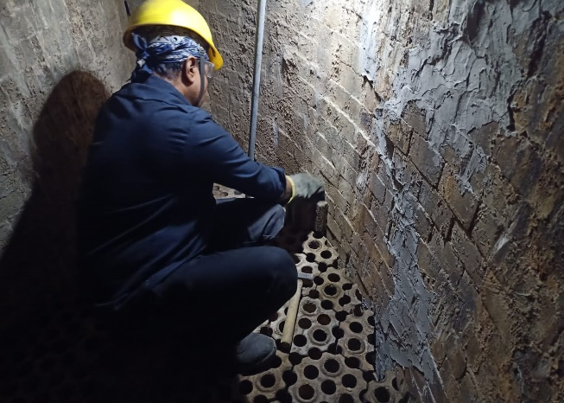 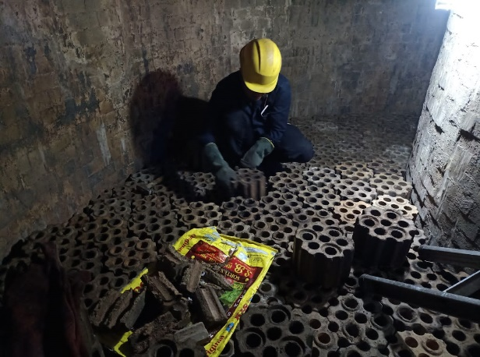

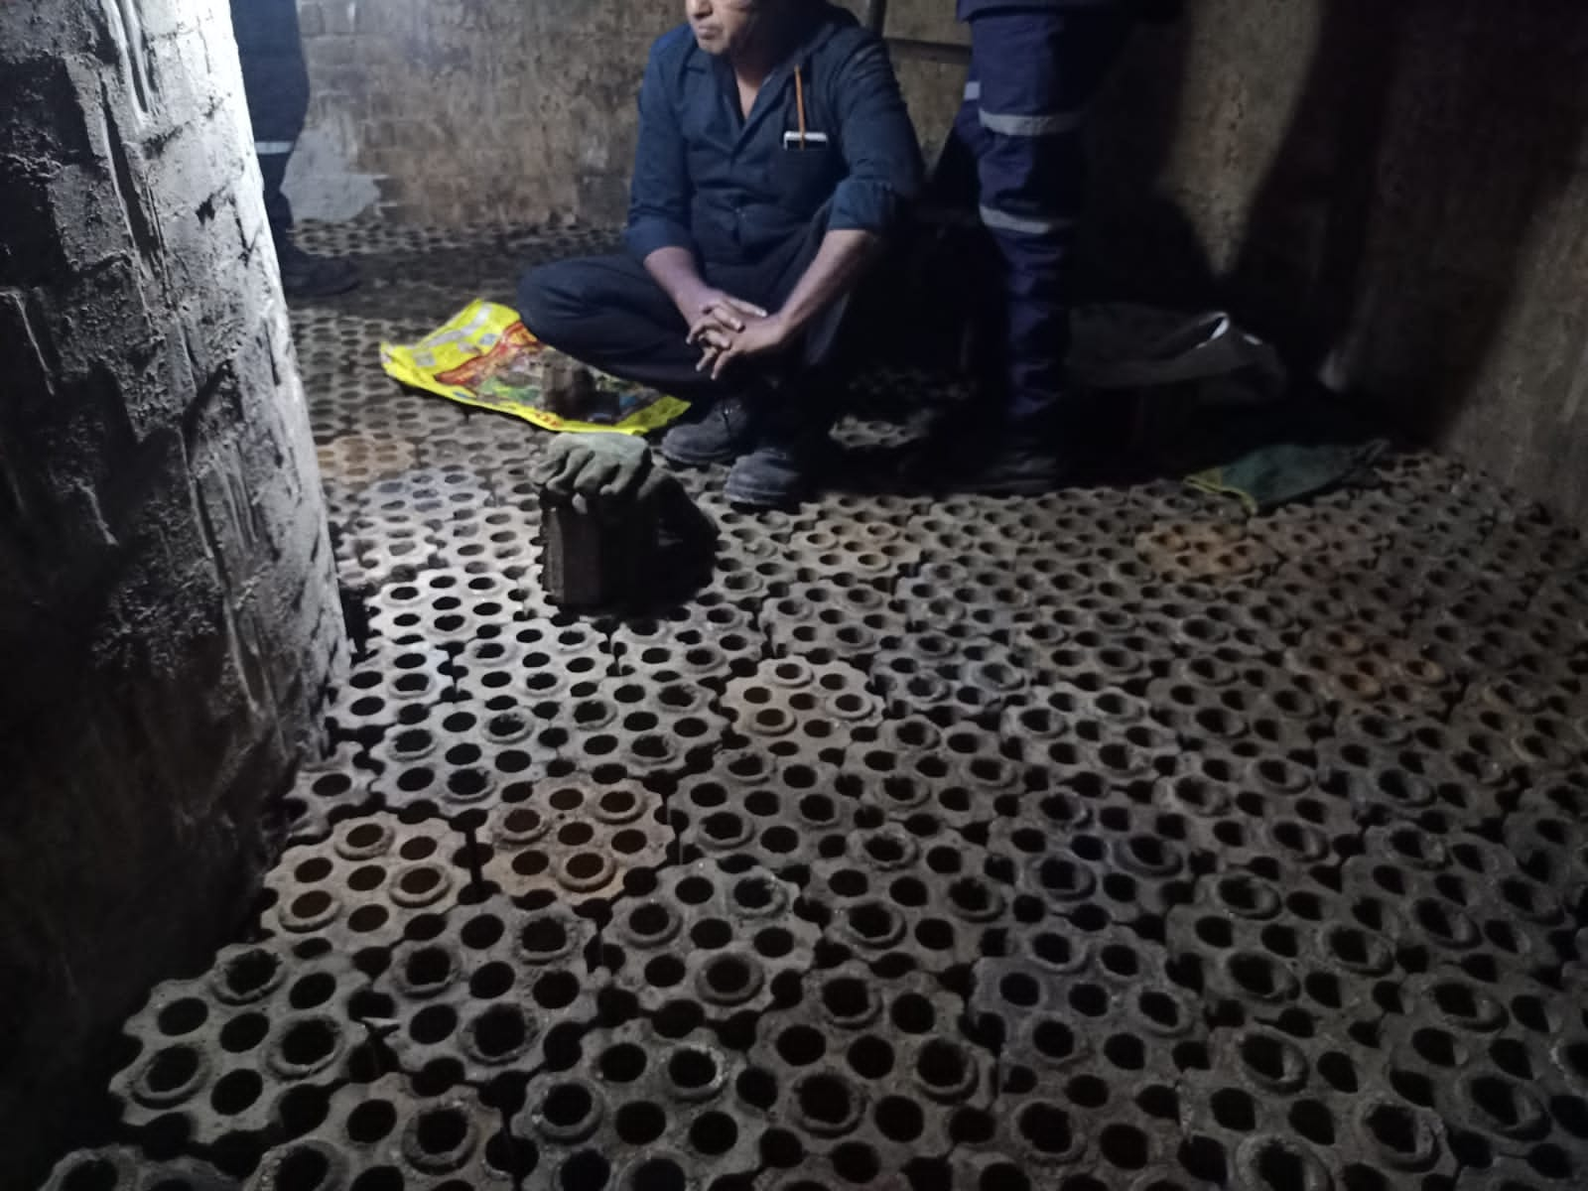 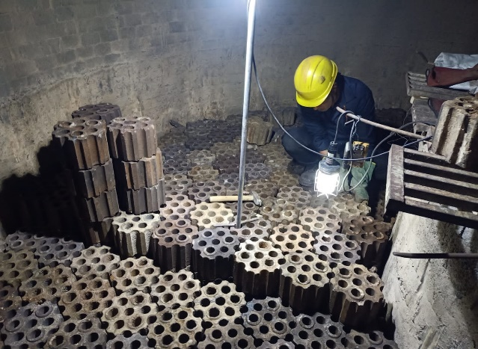

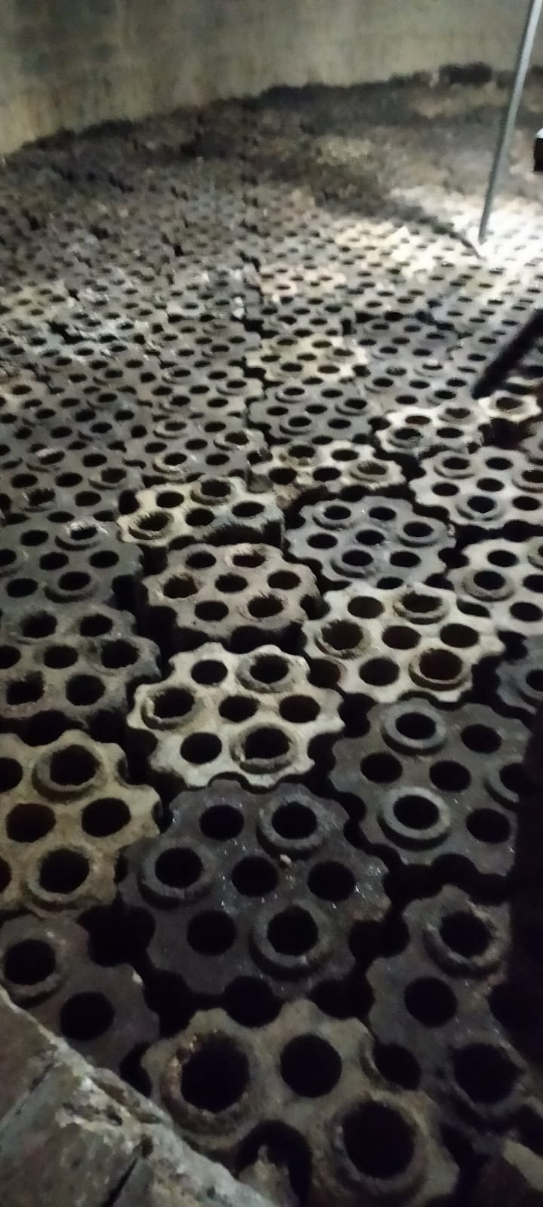

**Work No 4: Bustle main repair/ relining**

1. Bustle refractory repair/ reline job shall be taken up when furnace is under shutdown and permit taken from operation in-charge.
2. After shutdown, manhole at glendon area & blow pipes to be open. Refractory walls at the manhole to be dismantled (without disturbing the arch refractories).
3. Coffee pot valve to be open for maintaining natural draft through the duct.
4. The HBM & Bustle to be cooled to temp below 50°C before entering person inside. Raytek gun to be used for monitoring temp at different places.
5. Refractory repair activity to be carried out as directed by concern in-charge and in line with refractory drawing.

**Work No 5: Hot Blast main repair/ relining**

1. Hot blast main refractory repair job shall be taken up when furnace is under shutdown and permit taken from operation in-charge.
2. After shutdown, manhole at end & near APH to be open. Refractory walls at the manhole to be dismantled (without disturbing the arch refractories).
3. Chimney valve to be open for maintaining natural draft through the duct.
4. The temperature inside to be cooled to temp below 50°C before entering person inside. Raytek gun to be used for monitoring temp at different places.
5. Refractory repair activity to be carried out as directed by concern in-charge and in line with refractory drawing.

**Work No 6: Waste gas main & chimney (Stack) repair/ relining**

1. Chimney refractory repair job shall be taken up when furnace is under shutdown and permit taken from operation in-charge.
2. After shutdown, manhole at bottom to be open. Refractory walls at the manhole to be dismantled (without disturbing the arch refractories).
3. The temperature inside to be cooled to temp below 50°C before entering person inside. Raytek gun to be used for monitoring temp at different places.
4. Refractory repair activity to be carried out as directed by concern in-charge and in line with refractory drawing.

**DO**

1. Use 2 CO monitors every time. People working inside should carry at least one CO monitor.
2. Maintain good house keeping
3. Take shutdown of all valves & mechanically lock
4. Check hoist for proper rope winding
5. Provide CONFIEND SPACE ENTRY training to workmen.
6. Use 24V AC supply hand lamps.
7. Keep sufficient drinking water at workplace.
8. Check healthiness of cooling fan provided.
9. Check siren provided at top in case both cooling fan tripped

**DO NOT**

1. Throw bricks down
2. Use of mobiles while working
3. Overload the platform / hoist.
4. Urinate from stoves.
5. Use Nylon socks or clothing
6. Carry flammable liquid/lighters in the stove
7. Stack bricks over platform for more height.
8. Touch other near- by stove.
9. Enter confined space without confined space entry pass.

**HBS DRAWING**



|  |  |  |
| --- | --- | --- |
| **Prepared By:**  Head – Production PID I | **Reviewed & Issued By:**  Management Representative | **Approved By:**  Head – Pig Iron Division |
| **Signature:** | **Signature:** | **Signature:** |
| **Date: 10.07.2023** | **Date: 10.07.2023** | **Date: 10.07.2023** |

|  |  |  |  |
| --- | --- | --- | --- |
| **Amendment Record** | | | |
| **Revision date** | **Manual Section ref. and para** | **Brief details of revision** | **New Revision No.** |
| 15.07.2022 | Procedure for Refractory work in Hot blast system | HBS checker erection photos added, HBS drawing added | 06 |
| 15.07.2022 | Procedure for Refractory work in Hot blast system | Change in format | 06 |